Question 1
Q. : What are components in React? Explain the difference between functional components and class components.
Ans : In React, Components Are The Reusable Building Blocks Used To Create The User Interface (UI). Each Component Represents A Part Of The Web Page, Like A Button, Header, Or Form.
There Are Two Main Types Of Components:
🔹 1. Functional Components:
- These Are JavaScript Functions That Return JSX.
- They Are Simple, Easy To Write, And Use Hooks Like useState And useEffect.
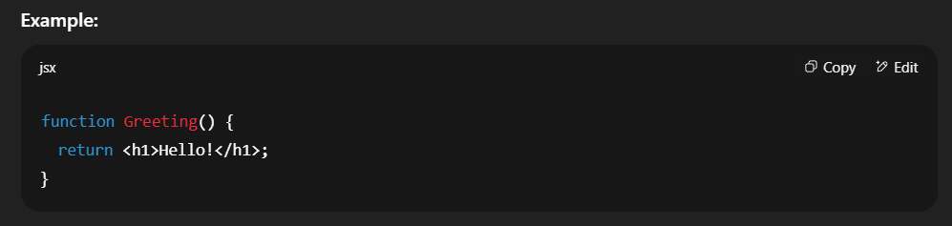
🔹 2. Class Components:
- These Are Created Using ES6 Classes That Extend React.Component.
- They Use A Render Method And Can Handle State And Lifecycle Methods.
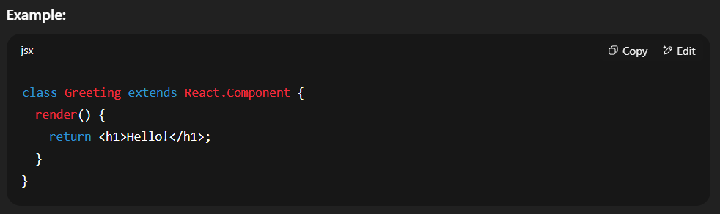

Basic Difference:
Point | Functional Component | Class Component
Syntax | Uses A JavaScript Function | Uses An ES6 Class
State Handling | Uses Hooks Like useState() | Uses this.state
Lifecycle Methods | Uses Hooks Like useEffect() | Uses Methods Like componentDidMount()
Code Simplicity | Simple And Short | More Complex And Longer
Recommended Use | Preferred In Modern React | Mostly Used In Older React Code

Question 2
Q. How do you pass data to a component using props?
Ans :
- Pass the Data From the Parent Component : When you use a component, you can add custom attributes (like HTML attributes) to it — these are the props.
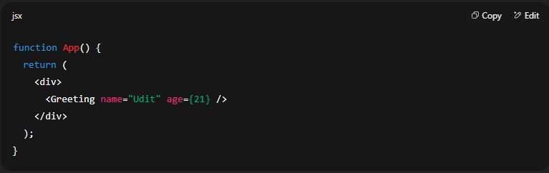
Here:
- name="Udit" → a string prop
- age={21} → a number prop (curly braces for non-string values)
- Receive and Use the Props in the Child Component : Inside the child component, you access props as a function parameter.
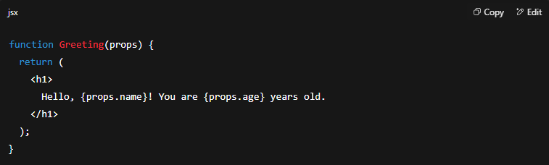

Question 3
Q. Discuss the importance of using curly braces {}in JSX expressions.
Ans :
In JSX, Curly Braces {} Are Very Important Because They Let Us Write JavaScript Expressions Inside HTML-Like Code.
This Means We Can Insert Dynamic Values, Variables, Functions, Or Even Conditional Logic Directly Into The UI. Without Curly Braces, JSX Would Only Show Plain Text.
